Test 2, Web Design Take Home Test

TASK: Using the “public speaking” theme from Test 1, you will create a responsive homepage with a similar layout.
IMPORTANT notes:
- There will be a some latitude for you to make some design decisions, but please be careful and make sure that you satisfy the minimum.
- It is best to start fresh instead of using your old test because there are some changes.
- You will be instructed on how to upload it to your stu.cofc.edu account. However, you will not list it on your assignment page. Instead, you will name it in a special way and use OAKs to let me know what your URL is.

Layout:
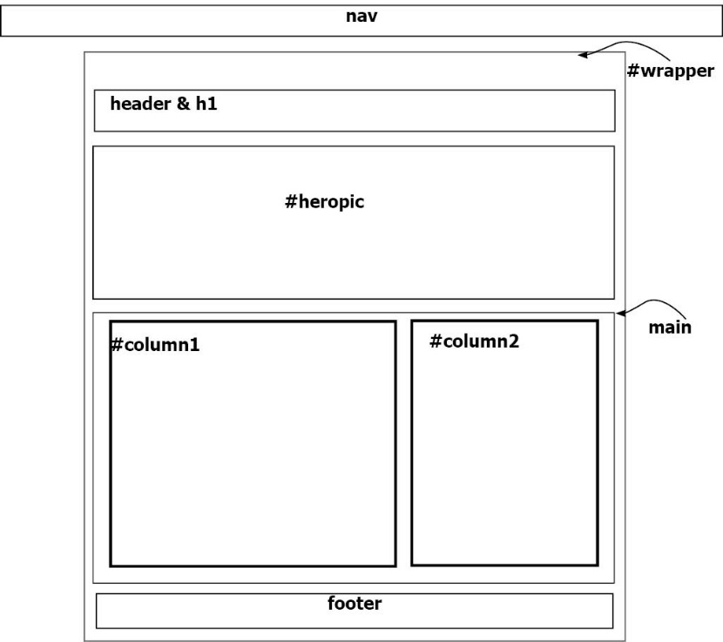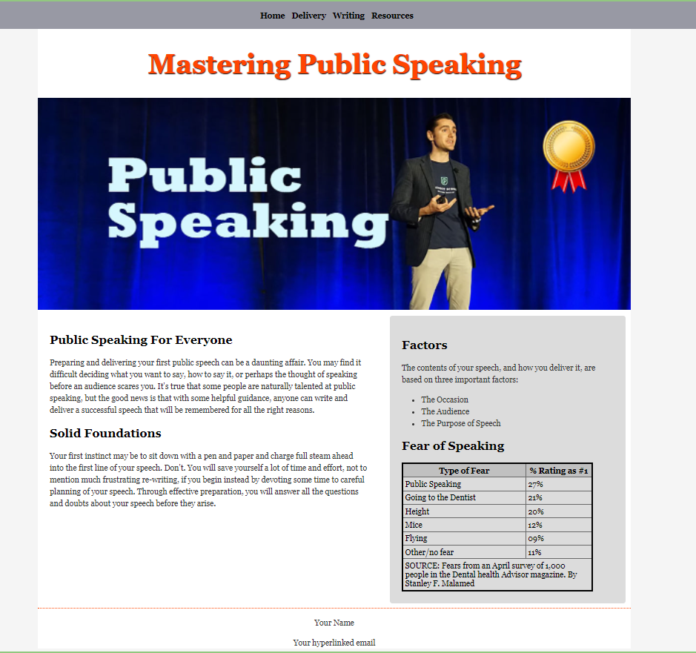

Prepare
- Download and unzip the files from moorec.people.cofc.edu/speak_responsive.zip
- Rename the folder to your grandmother’s birth month and day. (It’s OK to make it up.)
E.g., my grandma is 0513 for May 13th
- Description of files:
  - LargeHero.jpg is the hero image
  - index.txt will be pasted into your index.html file

Procedure and Requirements:

The HTML
- Create an HTML file with the <title> of “Public Speaking” and save the file as index.html
- Link a CSS file and call it test2.css
- Create a nav element, which is on top of the wrapper.
- Create a <div> with the id wrapper
- Using the illustration above as a guide, complete the remaining divs.
(You will configure the CSS later.)
- For the header and h1, type “Mastering Public Speaking”

- Create the navigation with unordered listing. The links in the nav element are as follows:
Home “index.html”
Delivery “#“
Writing “#“
Resources “#“

- In a <div> with the id heropic, insert the image LargeHero.jpg. You will later use CSS to make it responsive.

- Paste the text of the index.txt into column1 and column2 divs.
(It does not matter whether you keep the original comments or not.)

- In the footer element, type “Copyright © 2022. All rights reserved.” and your linked email address. Use a line break or paragraph to separate the lines.

- Create the following table at the bottom of #column2. You will set the styles later.
NOTES:
* The first row has <th> cells
* The last row spans 2 columns.

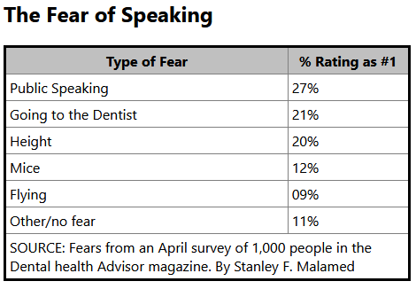

Color Scheme and Fonts
- Develop a color scheme based off of 3 colors.
- The colors must be hexadecimal or RGB. Do not use color names.
- Paste your color palette in a comment at the top of your CSS page.
- Then apply the 60-30-10 color rule in implementing it. (We only discussed this in the 10:30 class, but everyone can use Google to learn more about it.)
It’s OK to add neutral colors to your 3 colors.
- Fonts
- Choose two Google fonts. One will be used for body and the other for headings.

The CSS file
- body
  - Set the background color as desired
  - Set the primary font using one of your Google fonts
- p and li
  - Configure a multiple selector to set the p and li elements to a 150% line height.
  - Change the text to a grayscale color other than black.
- h1 and h2
  - Use one of your Google fonts to configure your headings
  - Optional: change color if desired.
- #wrapper
  - Set the width to 80%
  - Set the maximum width as 1200px;
  - Center the wrapper div. (Do not center the text.)
  - Set the wrapper top padding to 60px to accommodate the fixed nav.
  - Set background color as desired.
- nav
  - Center the navigation text
  - Set padding to 10px all around
  - Configure a background color as desired.
  - Create a fixed navigation that is 100% of the viewport. Offset at top and left of 0px.
- #heropic
  - Configure the #heropic as responsive

Horizontal Navigation configuration (descendant)
Not too much fanciness here. Simply make the nav horizontal and set the other typical styles. (It’s similar to Figure 6.32)
  - Remove the bullets from the unordered list
  - Display the list items as inline-block
  - Remove the underlines from the anchor
  - Change font color of anchors if needed
  - Add a left & right padding of 8px to the anchor tag
  - Format as bold

- Descendant h1 in header
  - Increase the h1 text size to 55px
  - Center the h1
  - Set the color, even if you choose black
  - Add a shadow of your choice to the h1. You may keep it subtle if you wish.
- main
  - Set main display to flex
  - Set direction to row
- #column1
  - Configure column1 with a flex of 6 (note that the columns will be 60%/40%)
  - Add padding of 1.5em all around.
  - Add a margin of 1em all around

- #column2
  - Configure column2 with a flex of 40%
  - Add padding of 1.5em all around.
  - Add a margin of 1em all around
  - Set a background color based on your color scheme.
  - Set the border radius to 8px.
- Table styles
  - Set the table width to 90%
  - The width of each column does not matter because we did not cover that in class.
  - Optional: change table background color;
  - Shade the first row by adding a background color to the th element
  - Add cell padding of your choice
  - Set a border around the table
  - Set a border around the th and td
  - Collapse the table borders
  - Set a hovering background on each row except the first. We’ve never done this in class, but it gives you another chance to use two types of pseudo classes. Here’s how: www.youtube.com/watch?v=VR36oHvWO5M
- footer
  - Add a border on the top only
  - Center the text
  - Set the height to 125px

- Media queries
You will create one set of media queries for smaller devices.

  - Set the break point of maximum 550px. Then configure these specifications:
    - Remove the minimum widths for all elements. (use wildcard)
    - Set the h1 font size to 30px
    - Set the #wrapper width to 100%; then set the top padding to 20px;
    - Set main flex direction to column
    - Set nav position to static so that navigation will no longer be fixed.
    - Set the nav width to auto
    - I know you’re tired. So, type this: #column1, #column2 {margin: 0; padding: .5em;}
- Don’t forget to validate your page.

SUBMITTING INSTRUCTIONS
- If you haven’t done so yet, put your test folder into your assignment folder
- Upload using FTP.
- Do not list it on your assignment page. Go to the Assignment Dropbox called Test 2 Responsive Speaking and type your URL.

