PROJECT 4, Photoshop Practice Exercise
This chapter deals with compositing – process of combining multiple images into a single cohesive design. Some of the primary skills included are selecting/isolating/silhouetting parts of images.

- Download & unzip file.
- New file US Paper (for 2017, choose Print>Letter which is auto 300pi)
- 300px
- CMYK color mode
- Name: Liberty Ad
- Set “BACKGROUND COLOR” to CMYK 0, 35, 0 100.
- Add Ruler guides .25” from all edges
(I’ll tell you about how it’s done in textbook in reference to trim size.
Also, if hard to drag, click VIEW>New Guide. )
- Lock the guides (View menu)
- Open multiple files at the same time: Quill, Bottle, and Parchment.
- Click WINDOW>Arrange @4-up, then…
  - Parchment – Drag to Liberty Ad.
  - Bottle – use Rectangular Marque to draw around. Also use Subtract From, to cut out about an inch. (just to see how it works. ) Then copy/paste
  - Quill – use Lasso to select irregular shape. Then copy/paste
  - Close unneeded files
- OPEN title.ai, to 8", 300px; drag to Movie Ad
- PLACE embedded Rater, Sunwhite, & Tantamount
(Then I’ll tell you about OPEN = raster; PLACE vector = vector)
- Name & Group layers
(It’s best for me to tell you what to call each)
- Hide all layers except Parchment
  - Transform to 8.5 width.
  - Quick Selection. Use it to select the black area.
  - Use “Refine edge” to keep it from being choppy.
  - On White background for preview.
  - Experiment
  - Inverse Selection, if necessary & Delete
- NOTE: There are many ways to isolate (silhouette)
  - You’ve already used Rectangle Marquee to trim about an inch from bottle.
  - You’ve already used Lasso to make irregular shape around feather. Same as above.
  - You’ve already used Quick Selection for Parchment.
  - In the next steps, you will use Pen Tool to draw Vector Path as well as Color Range for Quill.

- For Bottle layer, we will Draw Vector Path
  - Hide all but Bottle.
  - Pen tool. Use it to select bottle. Good for hard edges
  - From Control Panel, choose the Path option. Choose “Combine Shapes”
  - When done, use Direct Select to correct bad stuff
  - Open Paths panel
  - From options menu, Save the path. Then name it.
- Create a Layer Mask
  - On Layer Panel, be sure bottle layer is selected
  - Be sure bottle outline path is selected.
  - Click Layer>Vector mask >Current Path
  - (If time permits, I’ll talk about the flexibility of vector masks. Disable and enable it. )
- Quill layer. Hide others… including the background.
  - Try the Magic Wand to select & delete; notice it’s NOT the best. So UNDO.
  - Choose SELECT>Color Range
    - UNCHECK Localized, & set Fuzziness value to 60 (fuzziness is like tolerance/variation)
    - Choose White Matte for selection preview, because it’s easier to see
    - Be sure to click the sample (the blue part in document window)
    - Click Add+ to Sample. Keep clicking to see more blue;
also select the light blue shadow at bottom of feather.
    - Check Invert Color range (it shows what you want to KEEP). Click OK
  - Click Magic Wand, if necessary
  - Click Subtract From on Control Panel (BE SUUUURE!!!)
  - Click anywhere on transparent area to remove the blue from selection.
(Now only feather is selected)
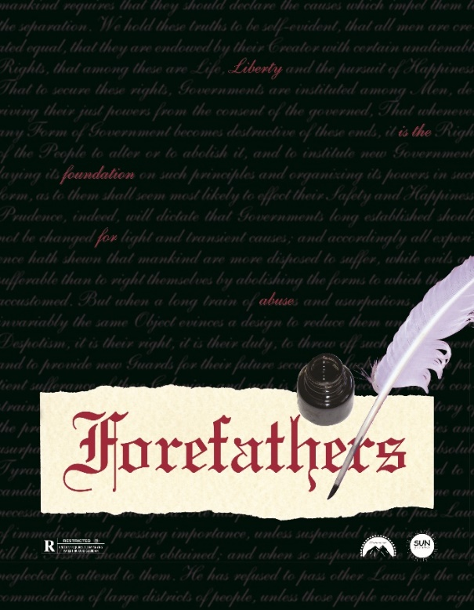
  - From Layers Panel, choose Add Layer Mask
- Show Background to see how well you did.
(If shadows of blue shows, you can use eraser to erase some more.)
- For each logo, resize as follows:
Sun = 13%
Tantamount = 20%
Rating = 45%
- Aligning logo layers, roughly position .ai files. Then align them vertically.
- Parchment and Title layers: transform, align vertically, group them
- Place Declaration as smart object
- Scale 100% so that it covers entire page.
- Move layer down. (It’s barely perceptible, but it keeps the “words” from appearing in the bottle.
- Flip Quill horizontally
- Finish positioning elements per illustration.

