I DO NOTT HAVE INSTRUCTIONS WRITTEN.
https://wordpress.com

Create account
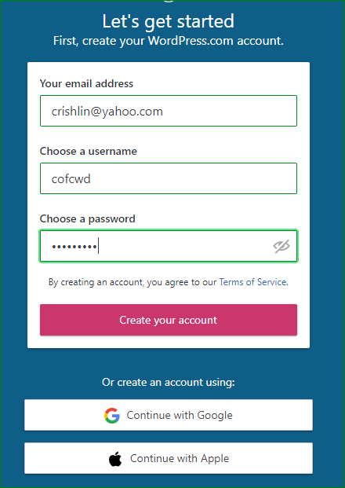

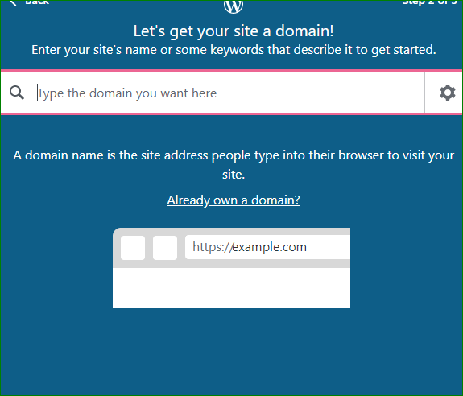
Type a DOMAIN NAME
They try to confuse you into choosing the pink blue green. But choose WHITE!
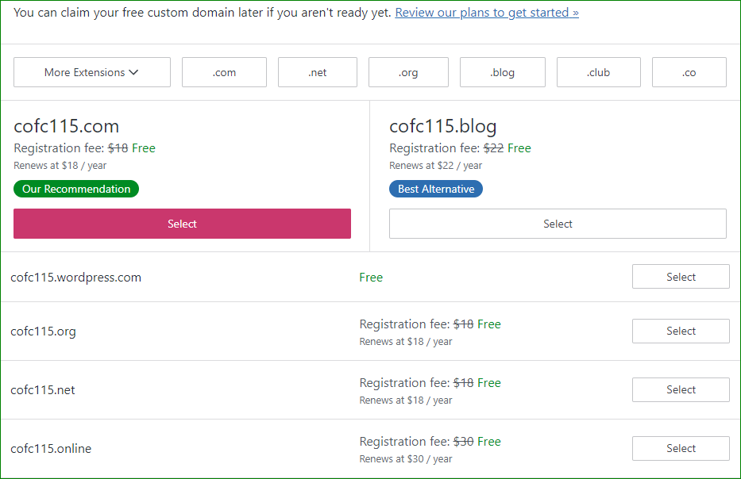
AGAIN, they try to trick you with big boxes. Choose little box

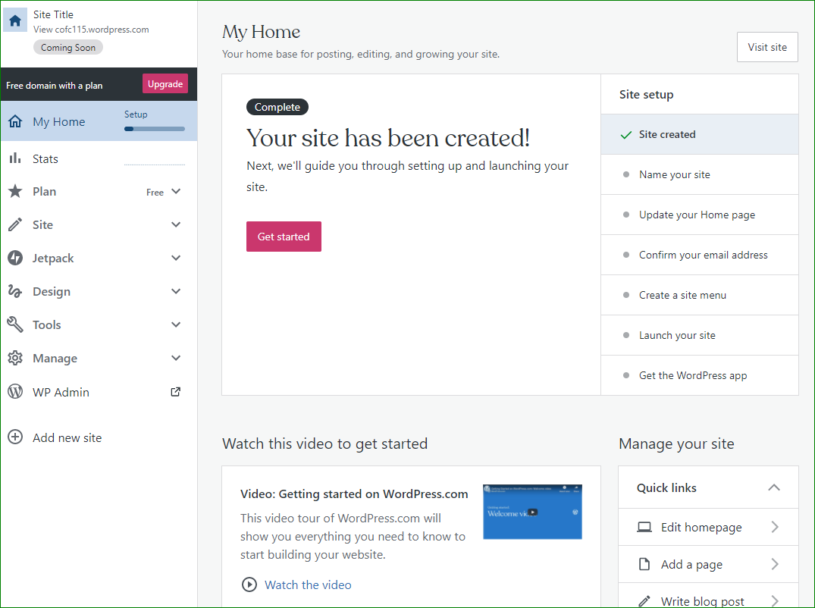
Click Get Started
It will guide you thru setting up, and you’ll also see the checkmarks/bullets on right side
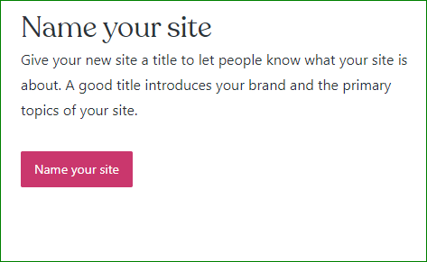The site name, which shows as the header.

It guides you with black boxes along the way. CONTINUE….
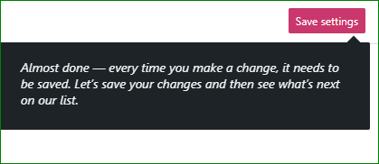

Note other settings on that page. It asks you to confirm you email;
You can now create a site menu. it does let you skip it, however.
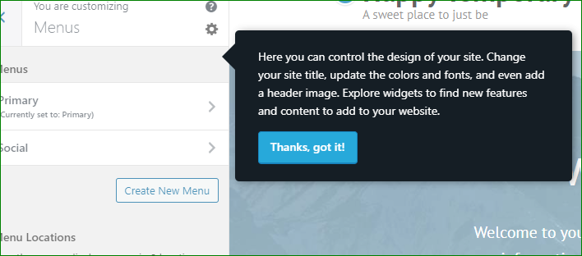

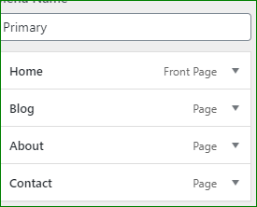 The menu is preset. Good
Just look at it and then go back Home and skip for now.

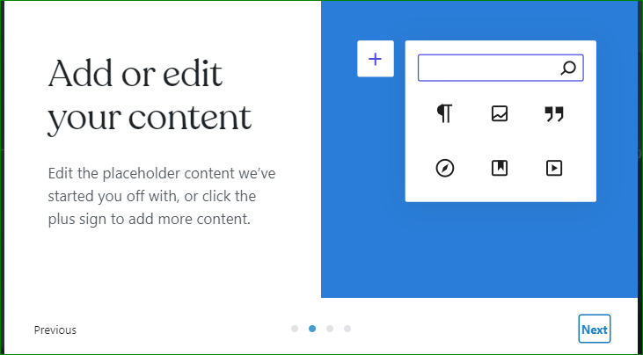

Go back at Update your Homepage.
When I have finished editing or adding, click Update.

SPECIAL: Those 3 cols that were confusing me: I had to hit Continue. Then it takes me to that page. Then scroll way down to the bottom and hit Edit.
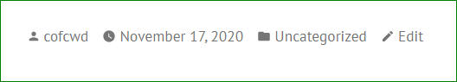 AND finally I am able to change it.
Updated, then hit the black W to go back Home.
To get to your other pre-built pages, click Site
LET’S do this to get variety of experiences:
- Keep Home
- Keep and change About
- Delete Blog and Content
- Make 2 -3 new pages

