Practice CSS Positioning
THIS WILL BE SUBMITTED BY THE 12:30 CLASS.
It must be complete based on all that we did in class.
In this short exercise, you will create a basic webpage and then design a fixed menu on the right. The header and footer will also be fixed
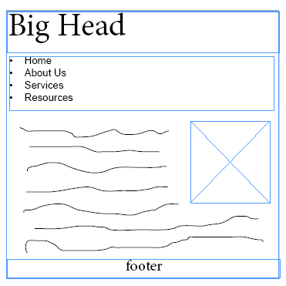
- Create a folder in chapter 6 called positioning.
- Find any random image with a width of roughly 300px;
- Build a basic webpage and call it whatever you wish. In the initial stages, it will look similar to the illustration below. But only do the styles that I describe.

The HTML
- Link it to a stylesheet called whatever you wish.
- Create these elements:
wrapper id
header, with h1 inside
nav after header
footer after nav
- From http://www.blindtextgenerator.com, get about 400 words and about 6 paragraphs.
- Create about 3 <h2> headings.
- Use <ul> to make navigation items.
- Put in a few words for <header> and <footer>
- Insert image, then create an inline style to float to right.

The CSS
Try to stick with my numbers, but feel free to change any colors
- Set wrapper to:
-80% width; max 1000px, min 700px
- any background color
- auto margins
- Set header background color to: rgba(255,215,0, .5)
- Set nav background color to: rgba(255,215,0, .5)
- Remove bullets from <ul>
- Remove underlines from <a>
- For paragraphs, I suggest:
-size of 120%
-line height of 140%
-If time permits, anything but black and Times New Roman
- For the footer,
- a background color of rgba(255, 177,98, .3)
- a height of 70px;
- top border of 3px groove #835C3B;
- Optional: if time, put your paragraphs in a <main> and add some padding.

What to expect next: Now it’s time for mostly new stuff. I will guide you in creating a fixed menu on the right side, and a fixed header and a fixed footer.
REFERENCES: https://www.w3.org/Style/Examples/007/menus.en.html
http://cssreset.com/how-to-keep-footer-at-bottom-of-page-with-css

