## ILLUSTRATOR: Collaborative Drawing Assignment

**For Each Individual:**

After my short demonstration, each person will create their own version of the bunny (See page 2). The main goal is to **use the techniques** mentioned in the list. However, feel free exercise your creativity and originality. For instance, it is okay to draw a rabbit on all fours or anyway you wish.

Please read the next step, because you will not be submitting as an individual, but as a group.

**For the Group:**

Each group will submit one single image containing each member’s bunny – nicely positioned on the page.

To prepare for submission, it would be nice if one member can draw some kind of grass or stage/platform. *The eggs are optional.* Even a simple green vector would suffice. An example is shown below, but you can be more elaborate if you wish.

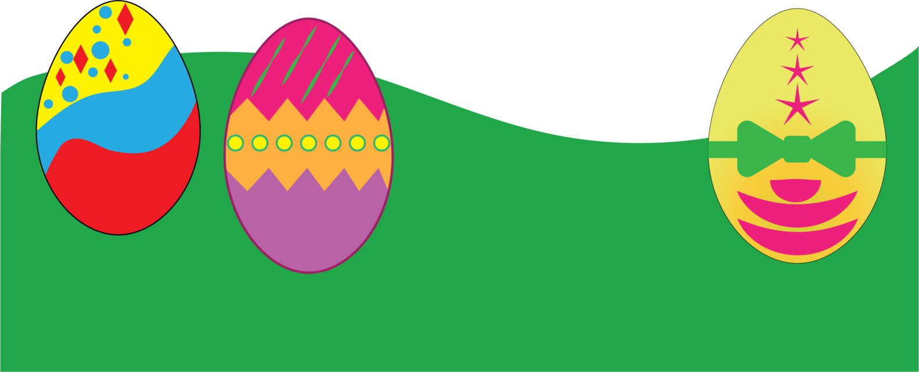

**Submit**:

Export the design as a JPEG or PNG. (**FILE>Export>Export as**)

Name your final group file: “**Final Group Bunnies”**

Do during class, and deadline is April 9th. The grade for the group is going to be Satisfactory/Unsatisfactory, and will count at 1% of your final grade.

# Demo and Actual Bunny

This is just an example so that I can point out a few techniques**.** You don’t have to draw the exact rabbit. You can be creative and draw your own. It’s got to be a rabbit, however. There will be time in the future for other types of drawings.



Flattened circles

Gradient

Don’t forget toenails.

Arcs

Consider round rectangle for fingernails

Nose. Triangle. Rotate, Convert Anchor Point

Chin. Add 2 anchors.

|  |  |
| --- | --- |
| For my demonstration, please do not touch your computer. Watch the 5 simple techniques that I will use to get you started. Then you’ll have more freedom, understanding, and creativity. (I.e. you won’t have to follow in lock-step fashion.) | |
| DEMO   * Chin (add two anchors; then pull down bottom anchor ) * Ears (Arc tool.  Then I joined them. (OBJECT/Path/Join) Then OBJECT>Transform/Reflect (copy) * Paws ( circle, then Direct Select to flatten) * Nose (Triangle; then radius; then rotate 180; then Anchor Point Tool to refine more)   **Remember:**  Anything that comes in pairs, you complete just one; then group if necessary, then copy or Clone. | LIST OF TECHNIQUES & SHAPES   * Hands and feet – one circle was drawn and transformed in different ways * Gradient * Arc * Transform: reflect * Transform: scale * Clone an item: Alt-drag * Drag, then Shift to keep parallel to original * Anchor Point to convert curve * Stroke, non-uniform (Illustrator has a ton of strokes. Plus you can find free ones online) * DON’T MAKE EVERY STROKE 1PX BLACK!! Use different strokes for more realness. .25 & .50 are great. Also, lighter colors like gray provide just a hint of a border. * Fingernails are round rectangle. Small radius |