Nation of March Madness
Notes: We will use these procedures to create a composite image using the US map and college basketball. You’ll mostly follow the steps as outlined. However they are written quite cryptically and often require explanation of both the steps and the broader concepts behind them. Occasionally, I will stop you no matter which step you’re on and require you to listen, so please be prepared to be attentive.

Preliminaries
- From the class website, download USMapBasketball.jpg
- Look at an NCAA bracket for women or men’s basketball and pick a team to come out of each region.
- Find an image of each of your Final Four picks and download them.
(Remember to save in the clouds if you are using a classroom PC.)

Stage 1
- Start with 11” X 8.5” in landscape image. Name it March Madness. 72 px is OK in order to keep file size down.
- Open USMapBasketball.jpg. Then copy it onto March Madness.
- Resize/Transform the map to fit the width of the page. Position the layer at top of page.
- Using the Freeform Pen tool, follow these steps to draw shape around the Hawaiian islands
  - Choose Shape layer from Control Panel.
  - Curve Fit, 2px. (turn of magnetic if necessary)
This defines how closely it matches your path.
  - No Stroke; No Style
  - Change foreground fill color to any weird contrasting color
  - You are getting ready to make a COMBINED shape around the entire US, including Hawaii and Alaska.
- From Control Panel, set Path Operations to Combine Shape
- Zoom in really big and draw around Hawaiian Islands.
- Continue +Combining parts of the map. For the contiguous U.S. Use the Freeform Pen tool, with Magnetic checked to draw around it.
  - Options: Width= 40, Contrast = 20, Frequency = 25
  - Click to start at any point on map. Hover around it, clicking occasionally to force anchor point.
- For Alaska, use any selection tool to Add+ its shape.
- When finished, Use Direct Selection and Convert Direction to fix mistakes
- Reduce the opacity of the layer to about 50 for the next activity.
- The next little activity is to demonstrate how to subtract from a shape. You will cut out Tennessee; then Undo to bring it back.
  - If necessary, deselect the map Shape 1 and make sure anchors are not showing. But stay on that layer.
  - Choose Freeform Pen Tool.
  - In the Control Panel, set Path Operations to Subtract from Front.
  - Drag to cut out Tennessee.
  - Set opacity back to 100 to see the effect.
  - Use History Palette to undo so that Tennessee comes back.
  - Then set opacity back at 100.

Resample shape layer & change canvas size
- Change the image size to a width of 12". Check Resample
- Another method of cropping is Canvas size.
With the top center being the reference point, reduce the canvas height to 7.5"

Color & texturize shape layer (I WILL EXPLAIN THIS TO YOU)
The goal is simply to pick a color from the map.
- Hide Shape layer (map)
- Use eyedropper to pick a color from your map.
- Show the layer again.
Then fill the shape (of the map) with the new color. ( press Alt-backspace)
- Then from the Style Panel, add a style.
If time permits, modify the style by double-clicking the layer to go into the Layer Style dialog box.

Stage 2, Get Started…
- Place Embedded your West and East basketball pick.
Recall that the image comes in as a Smart Object, which is nondestructive when you edit it.
- Paste or Open & Drag your South and Midwest basketball picks.
Recall that the image comes in as a rasterized image.
- Resize as needed. Anticipate that they will fit into US map later.
- Name the layers as: West, East, South, & Midwest to keep track of them.
- Hide all basketball layers except East
  - Make an oval around it with the Ellipse Marquee tool
(Please bear with me. I’m just emulating the book although some steps might not exactly fit what you wish to do with each image. So don’t worry about cutting off anything. You can get it back because this layer is nondestructive. )
  - SELECT/Modify/Feather. About 20px.
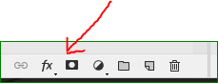
  - Experiment with Quick Mask, and then turn it off. Simply toggle “q” on and off.
The Quick Mask allows you to see the effect of selection.
  - Add a Layer Mask from the Layers panel.
- Do same for West. Use any selection tool you want, such as Lasso or Ellipse. Then repeat steps b-d from above.

Edit Layer Mask
- Continue hiding all layers except West.
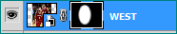
- Click once on the layer’s thumbnail. That is, the white cut-out area.

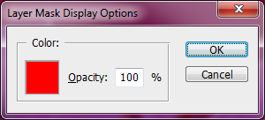
- Open the Channels panel.
  - Make the West channel visible.
  - If necessary, choose 100% opacity to show what’s happening to the selection. (Must double-click on Channel)
  - Choose a Brush tool. Then from the Control Panel, set to soft (0% hardness)
  - Set black/white default colors.
(Recall that white REVEALS selection; black CONCEALS.)
  - Drag the brush around a body part to trim closer (e.g. the head or between legs)
  - Switch to white to reveal more (e.g., more of a body part)
- Hide Channels and go back to Layer panel.
- Hide West layer because you’re finished with it for now.
- Now, edit the East layer like you did for West.

- Show South layer.
- Then use the Lasso to select the basketball player.
- Click on Refine Edges button (from the Control Panel)
(for CC2017, Click SELECT. Hold down SHIFT. Then Select & Mask to bring up Refine Edges. )
The purpose of Refine Edges feature is to clean up complex edges by using a combination of related options, such as feathering and radius.
  - Make adjustments as desired, especially with Feather and Smooth.
  - Output to Layer Mask. Press OK.
  - Notice that you have a non-destructive Layer Mask. For instance you can disable it and the entire image comes back.

Finish Trimming Images
- Use any selection method you prefer to finish trimming last image. (Should be Midwest layer. )

NOTE: If you have not hidden the original map layer yet, please do so now.

Convert layers to smart objects
- Convert remaining two layers (South & Midwest) to Smart Layers so that you can apply filters in a special way.
In the Layers palette, right-click on Layer and choose “Convert to Smart Object”.
- Then for each one, double-click on the Smart Object Icon to open in its own window.
Notice that the mask is still there.
You can close the new windows now.

In addition to converting your South & Midwest to Smart Object, you must convert the East & West as well. Reason is to move the Layer Mask into the smart object.
- Simply right-click on East layer. Choose Convert to Smart object.
The mask seems to disappear, but if you double-click on its smart object icon, you’ll see that it’s still there.
- Repeat for West layer.

Clipping Mask (to show only areas inside the US map)
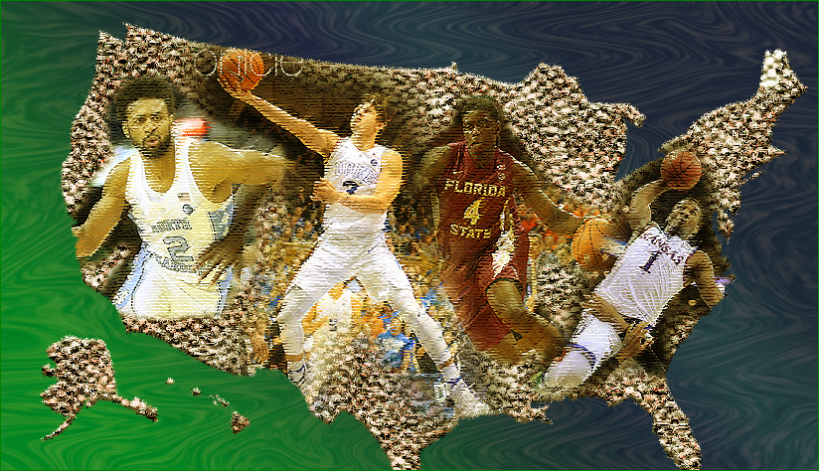
- Position and size layers attractively.
No need to fit 100% neatly into map because you’ll add Clipping Mask later.
For instance, I rotated my Kansas player a little to get a good fit.
- In Layers panel, highlight all 4 basketball layers
- Right click on one of them; choose Clipping Mask.
Note that all items are masked inside of USA map.
- PROBLEM: The texturizer hides all. That’s okay. Go to next step.
- In Layers panel, click Shape Layer 1 (i.e. the map)
- From menu, choose LAYER/Layer Style>Create Layers
- Click OK for warning.
Look at your Layers panel and notice what happens. You now have a layer for each effect of the map.
- If necessary, highlight all 4 layers and apply Clipping Mask again.
- Move and resize players as needed.

- Convert the map layer to Smart Objects in order to add the filters in the way that we will below.

Stage 3: Filters and Adjustments
- From the History panel, take a snapshot in History panel because you might not like your filters.
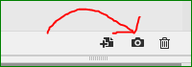
- For one of your “basketball layers” layer, apply: FILTER/Gallery. Then choose Artistic/ Dry Brush.
In trying to make the effects more subtle, I choose 1, 1, 1 for the numbers.
- In Layer panel, double-click the Filter Gallery. Play with options.
I choose Paint Daub, Rough. But you have lots of options to choose from.
- Choose “New Effect” filter (Try any filter you desire.)
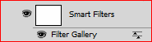
- As time permits, do the same filter to the other 3 teams.

A shortcut with Alt-drag is possible, but tricky. You must actually click the words “Smart Filter. Then Alt-drag to another layer.

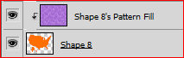
- Click on Shape 1 layer (the map). Click Filter/Stylize/Diffuse.
(difference not really perceptible. So press Ctrl-Z repeatedly to see it)
- If you have time, add another filter to Shape 1 Pattern fill.

Stage 4: Creating Artistic Background
These are a lot of brief steps, collectively aimed at overall enhancement of your montage. Try to follow closely, but if you miss something or go a different route, you will serendipitously end up with something awesome anyway.
- Create a new gradient with 3 color stops. You will use it for the ocean.
(For best results, the same blue on left and right; and green in middle.)
- On top of Background layer, add New Layer to be used for the ocean.
- Apply your gradient to the new ocean layer.
- Create another New Layer to be used waves. Fill with any color.
- Now, fill with pattern. (LAYER/Style/Pattern Overlay is best way).
- Drag waves layer below ocean layer.
- Stay on ocean layer, click Blending Mode. Choose Overlay.
(Don’t worry about it looking gaudy; it will be subdued.)
- Select waves layer and do more filtering if desired.
- Click FILTER/Blur>Gaussian Blur.
- Merge ocean and wave layers.
- Liquefy by choosing FILTER/Liquefy.
- If desired, add Drop Shadow and Stroke to the map (LAYER/Style/Drop shadow)
- Add new layer at top of stack.
- Fill with gold color.
- Blend with Soft light.

