Study Guide, Final Exam

The Final Exam is cumulative. The questions for chapters 1-11 will come from previous three tests only.

Examples of questions from Chapters 12, 13, 14, 15, and 17 are:

- 17, What are the 5 steps used in displaying text?
- 17, What is the meaning of concatenate?
- 14, In which function is the P3D parameter placed?
- 14, What are 2 of the ways in which angles can be specified?
- 12, Be able to identify the code used to import a library.
- 14, Use analogies to explain how rotateZ, rotateX, and rotateY differ?
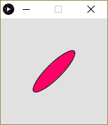
- 14, The following 4 lines are intended to draw a flower petal that looks like this the image to the right. Fill in the blank space below with the missing function which would allow a 45 degree rotation?
fill(#ff0066);
translate(width/2, height/2);
rotate(___________(45));
ellipse(0, 0, 20, 80);

- 13, The following lines of code can be used to cycle a counter variable back to zero.
x = x + 1;
if(x >= limit) {
x = 0;
}
However, there is a more efficient way to write using modulo. What is the code?

- 14, What is the name of the missing function in the code below?

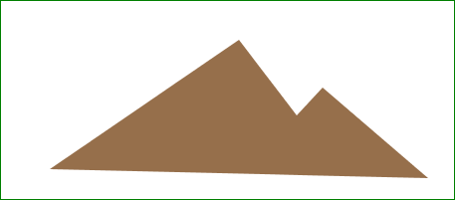
beginShape() ;
_________ (290,370);
_________ (348,446);
_________ (374,418);
_________ (480,509);
_________ (100,500);
endShape(CLOSE);

- 17, What is the name of the class for loading and displaying images?
  - PImage
  - Pixels[]
  - loadImagery()
  - createImage()
- 14, Which pair of functions is used to save the current matrix system and then to restore that saved matrix system.
  - Min and max
  - loadPixels and updatePixels
  - pushMatrix and popMatrix
  - beginShape and endShape
- 14, Which function specifies an amount to change the point of origin within the display window?
  - shear
  - transform
  - translate
  - offset

