## ILLUSTRATOR: Collaborative Drawing – Easter Theme

**For Each Individual:**

After viewing the videos, each teammate will create their own version of a bunny and at least one Easter egg. The main goal is to **use the techniques** mentioned in the lists of skills. However, feel free exercise your creativity and originality. For instance, it is okay to draw a rabbit on all fours or anyway you wish.

* The bunny example is shown on page 2, and the video is here:  
   <https://screencast-o-matic.com/watch/cFewhxD5UK>
* Examples of the eggs are below, and the video is here: <https://www.youtube.com/watch?v=ZkWFhSTY4kk>

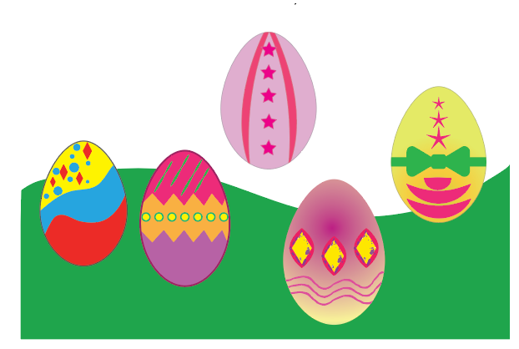

**For the Group:**

Each group will submit one single comprehensive vector image containing each member’s bunny and egg(s) – all nicely positioned on the page like a cartoon scenery.

To prepare for submission, it would be nice if one member can draw some kind of grass or stage/platform.*.* Even a simple green vector would suffice.

**How to Submit**:

**Due date:** April 6

Export the design as a JPEG or PNG. (**FILE>Export>Export as**)

Name your final group file: “**Final Group Bunnies”** so that I’ll know which one to grade.

*There is no need for your illustrator file this time around.*

The name of the folder is: **Illustrator Design Easter**

Satisfactory/Unsatisfactory, and will count at 1% of your final grade.

# Demo and Actual Bunny

This is just an example so that I can point out a few techniques**.** You don’t have to draw the exact rabbit. You can be creative and draw your own. It’s got to be a rabbit, however. There will be time in the future for other types of drawings.



Flattened circles

Gradient

Don’t forget toenails.

Arcs

Consider round rectangle for fingernails

Nose. Triangle. Rotate, Convert Anchor Point

Chin. Add 2 anchors.

|  |  |
| --- | --- |
| [Watch the simple techniques](https://screencast-o-matic.com/watch/cFewhxD5UK) that I will use to get you started. Then you’ll have more freedom, understanding, and creativity. (I.e. you will not have to follow in lock-step fashion.) | |
| DEMO   * Chin (add two anchors; then pull down bottom anchor ) * Ears (Arc tool.  Then I joined them. (OBJECT/Path/Join) Then OBJECT>Transform/Reflect (copy) * Paws ( circle, then Direct Select to flatten) * Nose (Triangle; then radius; then rotate 180; then Anchor Point Tool to refine more)   **Remember:**  Anything that comes in pairs, you complete just one; then group if necessary, then copy or Clone. | LIST OF TECHNIQUES & SHAPES   * Hands and feet – one circle was drawn and transformed in different ways * Gradient * Arc * Transform: reflect * Transform: scale * Clone an item: Alt-drag * Drag, then Shift to keep parallel to original * Anchor Point to convert curve * Stroke, non-uniform (Illustrator has a ton of strokes. Plus you can find free ones online) * DON’T MAKE EVERY STROKE 1PX BLACK!! Use different strokes for more realness. .25 & .50 are great. Also, lighter colors like gray provide just a hint of a border. * Fingernails are round rectangle. Small radius |