Type on top of picture

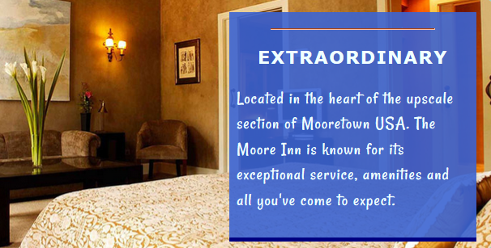

You can use different techniques to overlay text on an image. One is to set the image as a background, then simply using margins and padding to position the textbox. It’s OK to do it that way. However, it’s not a good idea to go overboard with using images as backgrounds because they are not printed by default.

The most effective way of typing on a picture is to use CSS positioning.

This is the code. I didn’t write many comments but will take a little while to explain during class. Since we’ve already covered positioning, you may simply copy and paste the code. Use your own moderately sized image to make it interesting.

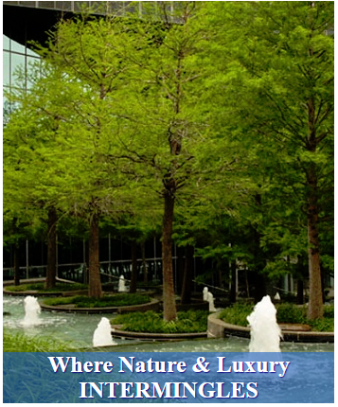

<style>
#holder {
height: 425px;
width: 350px;
position: relative;
}
#thePic {
position: absolute;
top: 0;
left: 0;
}

#text {
/*The essentials */
position: absolute;
bottom: 0px;
left:0px;
background-color: rgba(20, 105, 200, .6);
width: 100%; /* or pixels OK*/

/* The accoutrements */
color: white;
font-size: 24px;
font-weight: bold;
text-shadow: 1px 1px 1px navy;
text-align: center;
}
#holder p {
margin-bottom: 0;
}

</style>

<div id="holder">
<img id="thePic" src="pool.jpg" >
<p id="text">
Where Nature & Luxury<br>
INTERMINGLES
</p>
</div>

